Further joint submission to the Work & Pensions Select Committee Inquiry into the Disability Employment Gap

In the oral evidence session on 24th Feb 2021, three of us explained our concerns with the Government’s main measure of assessing its success in raising employment among disabled people, namely, the ‘disability employment gap’. Following this, the Chair noted, “If any of you are able to put on paper what you think the target ought to look like and what the definition ought to be, that would be very interesting to us.” This document is a collective response (with our co-authors) which sets out:
- Our proposed headline measure(s);
- Calibrating the main measure of disability;
- A wider basket of indicators to track changes in disability inequality in the labour market.

Our proposed headline measure(s)
The problem with the ‘disability employment gap’ measure is that in recent years, more people have said that they have a disability (as shown in Melanie Jones and Vicki Wass’ written submission to the inquiry). The possible explanations for this increase are complex, but probably reflect a change in how people describe themselves, rather than a real change in the prevalence of underlying functional limitations. The extra people saying they are disabled are likely to have less severe disabilities (as they are on the border in terms of reporting disability), and hence have higher employment rates than other disabled people. So, because these people now report disability, the disability employment gap falls – even if employment is no more likely for the same disabled individual.
There is an alternative measure that is relatively unaffected by this reporting change – the proportion prevented from working by disability (PWD). This is simply the prevalence of disability, multiplied by the conventional disability employment gap. It has the advantage over the disability employment gap that it takes into account whether more people report they are disabled or not.
The difference that using the PWD measure makes is shown in Figure 1 below:
- Using the current disability employment gap measure, we see a sustained improvement, with the disability employment gap narrowing from more than a 40 percentage point gap in 1998 to less than 30 percentage points in 2020.
- Using the PWD measure, we see a smaller improvement 1998-2010 (6.4% of all working-age people were prevented from working by disability in 1998, falling to 5.6% in 2010). Since 2010, we see no systematic improvement whatsoever.

Figure 1: Comparing the current disability employment gap measure with PWD
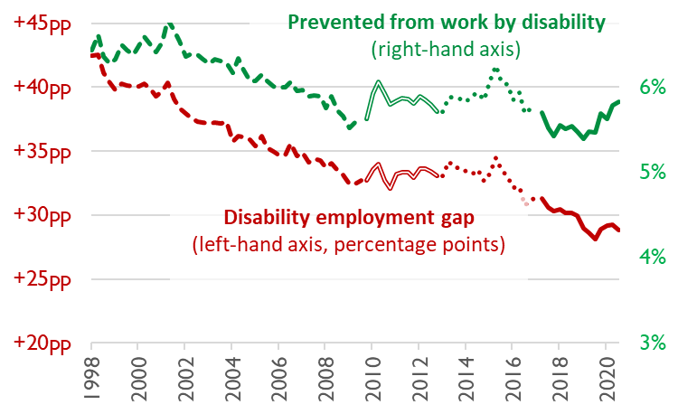
Figure uses ONS data, labour market statistics table A08. Different line styles show discontinuities in the LFS data; the figure is ‘chained’ so that the earlier series continues where the more recent series stops.
It is not just that PWD allows for changes in disability prevalence, but it also seems more consistent with trends in other, related indicators. For example, trends using our alternative measure more closely mirror trends in the proportion of people receiving incapacity benefits than the conventional disability employment gap. Similarly, PWD shows much more consistent trends across major government surveys, whereas the disability employment gap sometimes shows completely different trends in different surveys for no clear reason.

We do not agree on exactly how these measures should be used:
- Geiger and Wass believe that the PWD should be the single, headline measure, because it provides more useful data for policy than the disability employment gap.
- Bryan and Jones believe that the PWD is an important measure, but one that is not as easy to understand as the disability employment gap, and which is still imperfect. They believe that there should be three headline measures of disability and employment: (i) PWD, (ii) the disability employment gap, and (iii) the prevalence of disability.
However, we are all agreed that the PWD is a valuable measure for policy, whether or not it replaces or supplements the disability employment gap measure.

Calibrating the main measure of disability
Our suggestion for this additional measure is very simple and easy to implement using existing data. However, we need to better understand trends in the underlying self-reported measure of disability used in Government surveys. There are alternatives that use less vague questions to minimise inconsistent interpretations (as recommended by the Washington Group on Disability Statistics, a UN agency) and identify functional limitations from which to benchmark and understand changes in the self-reported measure.
While there is unlikely to be the space to ask all of these questions in all Government surveys, a pragmatic solution would be to periodically ‘calibrate’ the headline measure against functional measures of disability. This would help us to understand what the conventional disability measure means and how that meaning changes over time.
As a first step, it would be easy to calibrate 20 year trends in working-age disability using the Health Survey for England (HSE) (see written submission by Jones & Wass). Functional limitation questions were asked in 1996/2000/2001 but never since repeated; simply repeating these measures would provide a good check on the twenty-year trends in disability prevalence which underpin Figure 1.

Other measures in a basket of indicators
We also want to stress that the PWD – whether as a single headline measure, or as one of three key measures – should be complemented by a basket of indicators around disability and work, to provide a deeper understanding of changes in the labour market inequality associated with disability over time. This could include:
- Employment gaps, prevalence and corresponding PWD measures for particular disabilities, e.g. mental health;
- How the disability employment gap and proportion prevented from working due to disability varies across other inequality strands (given evidence that the disability employment gap is higher for men; older workers; those with low education; and in North-East England and Northern Ireland; see the written evidence submission by Roberts, Bryan, Bryce, Rice and Sechel);
- How the disability employment gap is affected by differences in job loss and job gain, by measuring disability gaps in the probability of entry to and exit from employment (see written submission by Jones and Wass).
- Disability pay gap (given evidence of a sizeable disability gap in hourly earnings; see the written submission by Jones & Wass);
- Other indicators of job quality, including disability gaps in zero hours contracts, temporary jobs (see the written evidence submission by Roberts, Bryan, Bryce, Rice and Sechel) and wellbeing at work (see the written submission by Jones & Wass).
All these indicators are readily available in existing datasets and should be published annually, alongside the disability employment gap, disability prevalence and PWD.

Please do not hesitate to contact us if you require any further information.
Ben Baumberg Geiger (University of Kent), Melanie Jones (Cardiff University), Mark Bryan (University of Sheffield), Vicki Wass (Cardiff University),18th March 2021

We have a formal estimate of the bias on the new measure, but put simply: if we assume that the people wavering about reporting their disability have similar employment rates to non-disabled people, the PWD measure is unbiased. While this is not likely to be quite true in practice (and therefore the PWD measure will be slightly biased), the extent of bias in 21st-century Britain is likely to be much smaller than when using the disability employment gap.
By ‘conventional disability employment gap’, we mean the difference in employment rates among disabled people vs. non-disabled people.
See Oakley (2021), Time to think again: Disability benefits and support after COVID-19, Social Market Foundation, p22.
See Disability prevalence and disability-related employment gaps in the UK 1998-2012: Different trends in different surveys? (Baumberg Geiger, Jones & Wass 2015). Social Science & Medicine, 141:72-81
That is: it still fundamentally relies on a single self-reported measure of disability, and as we said in footnote 1, it will therefore still be subject to some biases, even if these are smaller than for the disability employment gap.

